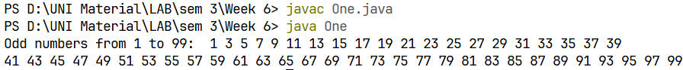
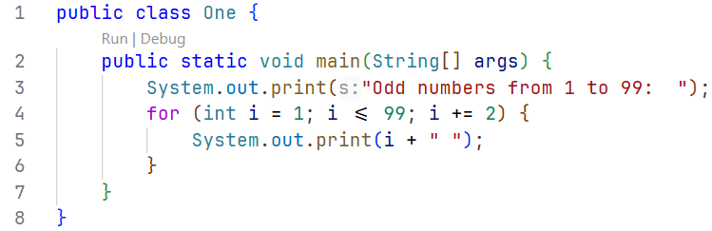
Output:
Question 1:
Write a Java program to print the odd numbers from 1 to 99.
Code:
Week 6

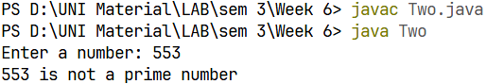
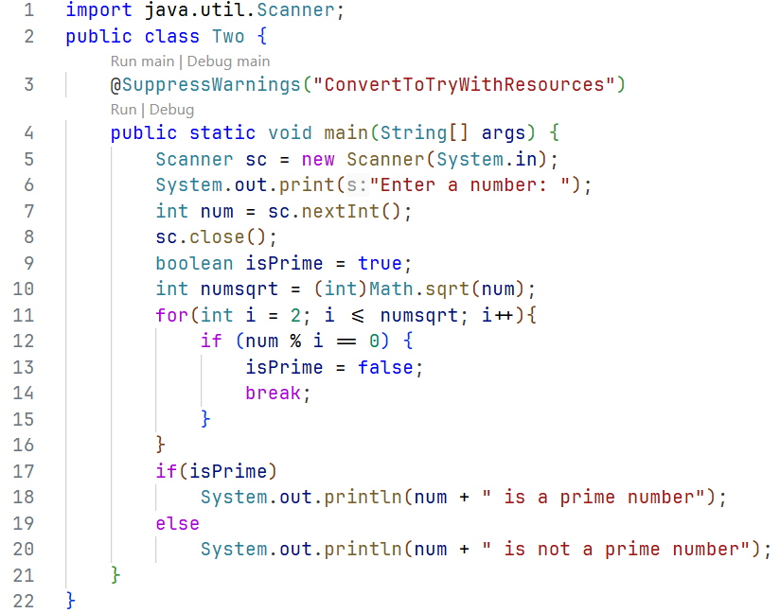
Question 2: 1
Output:
Code:
Write a Java program to check whether a number is prime or not.

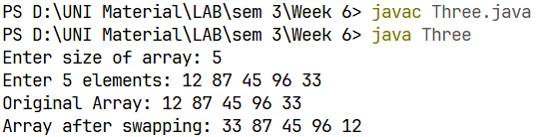
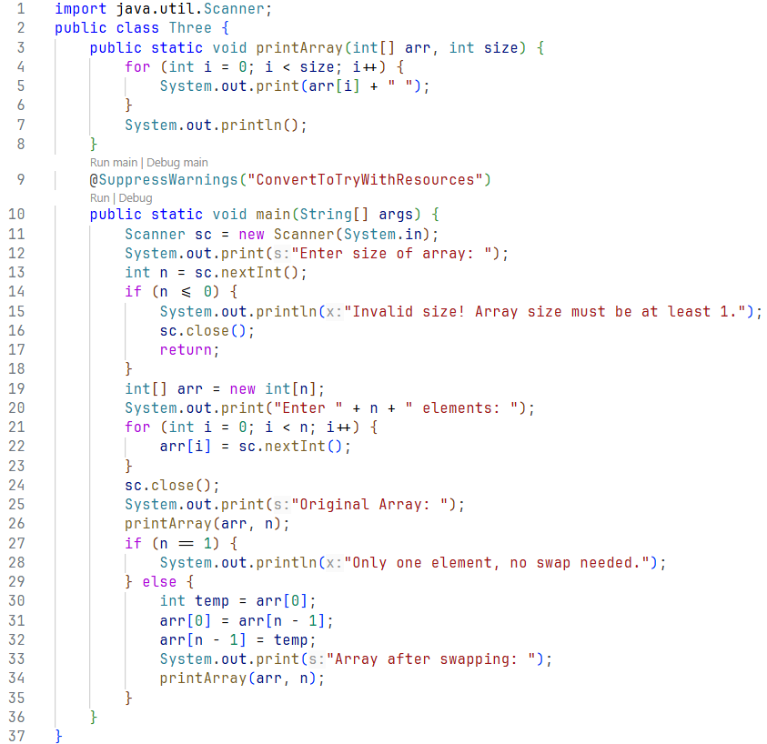
Code:
Question 3:
Write a Java program to swap the first and last elements of an array.
Output:

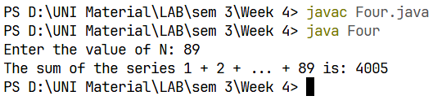
Output:
Question 5:
Write a Java program to take a number, divide it by 2 and print the result until the number becomes less than 10

Code:
import java.util.Scanner;
public class Five {
public static void main(String[] args) {
try (Scanner scan = new Scanner(System.in)) {
System.out.print("Enter a number: ");
int number = scan.nextInt();
if(number < 10)
System.out.println("Number is less than 10, please enter more than 10");
while (number >= 10) {
System.out.print(number + " / 2 = " + (number/2) );
number = number / 2;
}
}
}
}

Question 4:
Code:
Write a Java program to find the maximum and minimum among array elements.

Output:
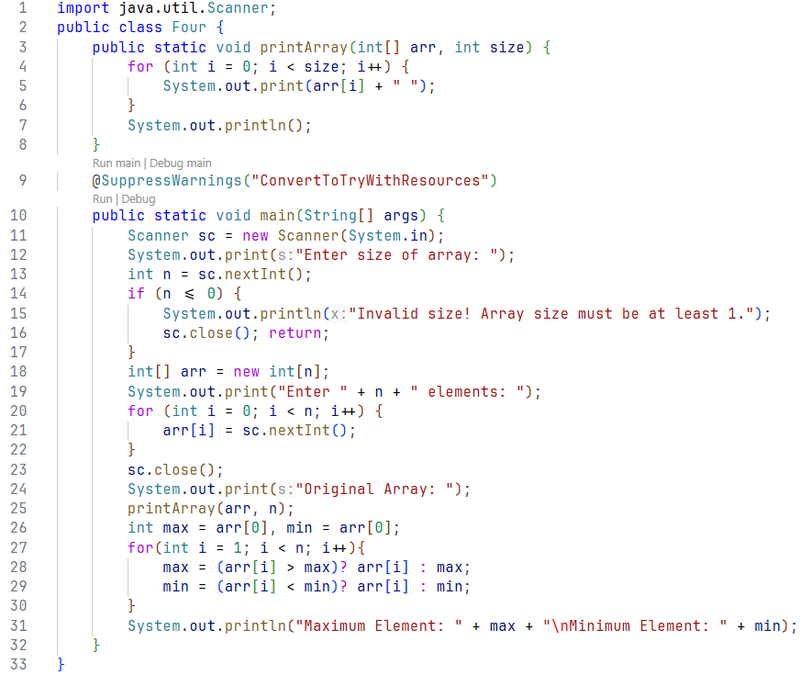

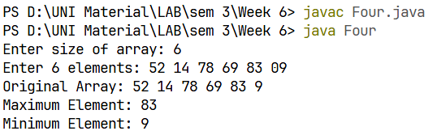
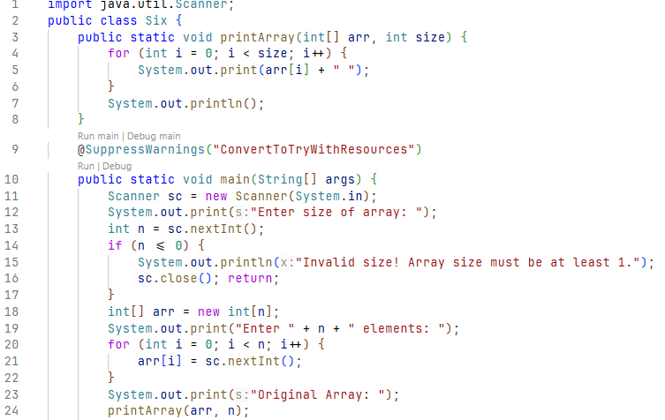
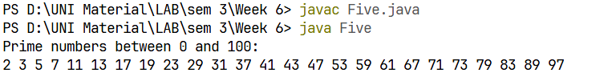
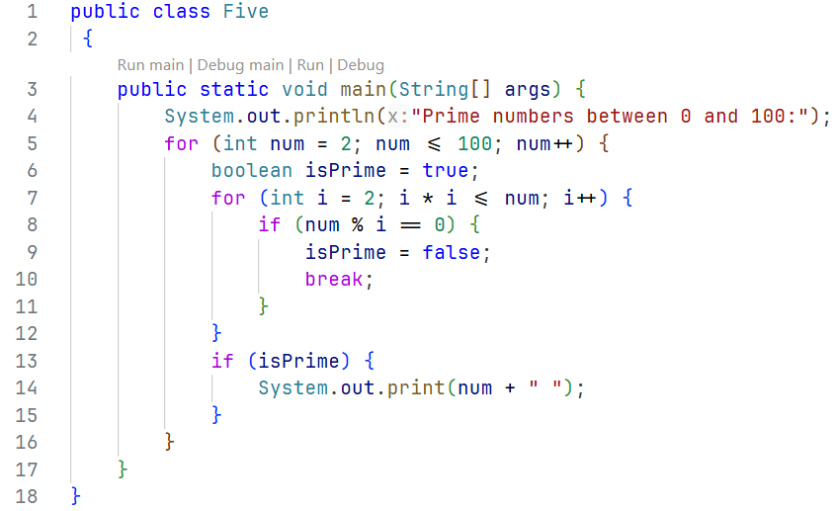
Code:
Question 6:
Write a Java program to implement linear search.
Output:
Code:
Question 5:
Write a Java program to print all prime numbers between 0 to 100.
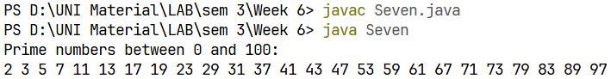
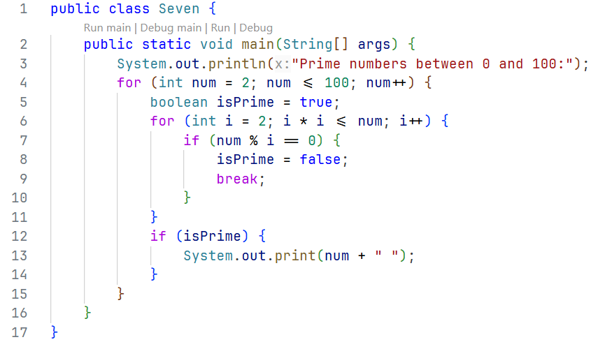
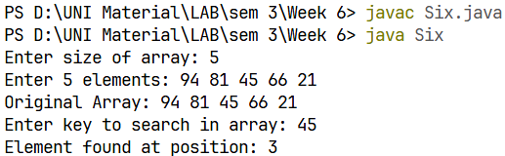
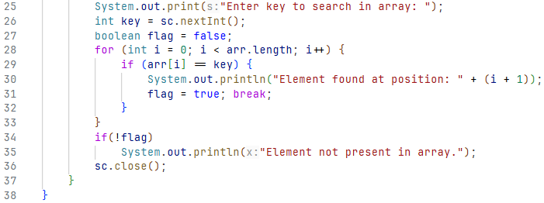
Output:
Code:
Write a Java program to print all prime numbers between 0 to 100.
Question 7:
Optional
Output:
Code:
Write a Java program to find the second largest element in an array.
Question 8:
Code:
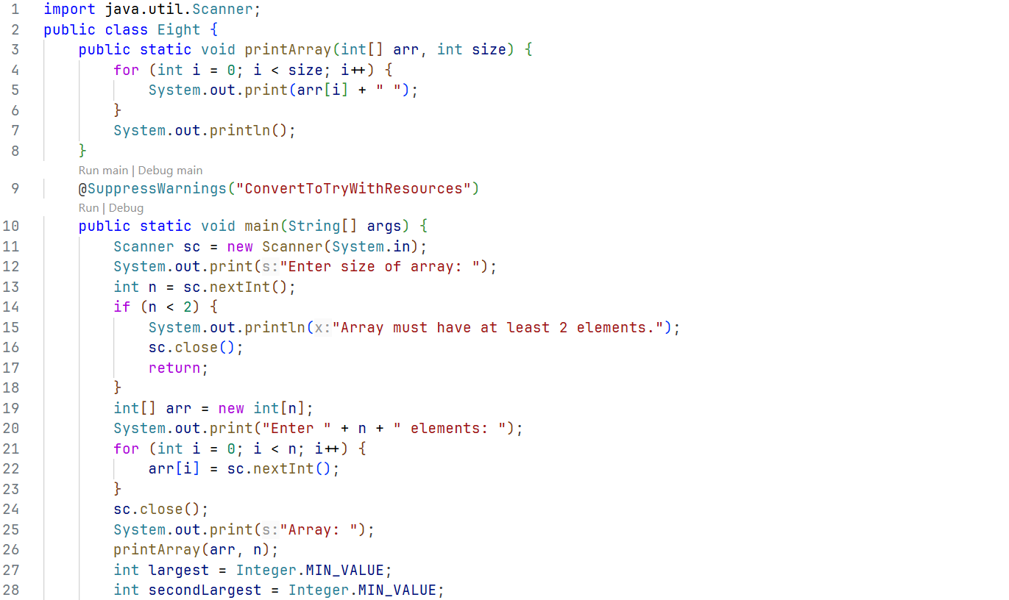
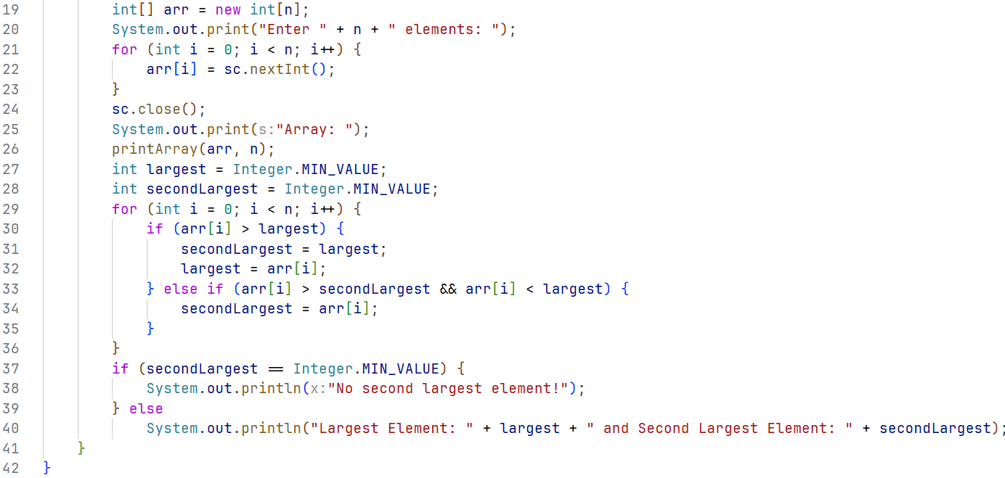

Output:
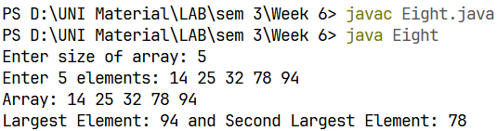

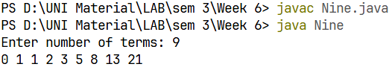
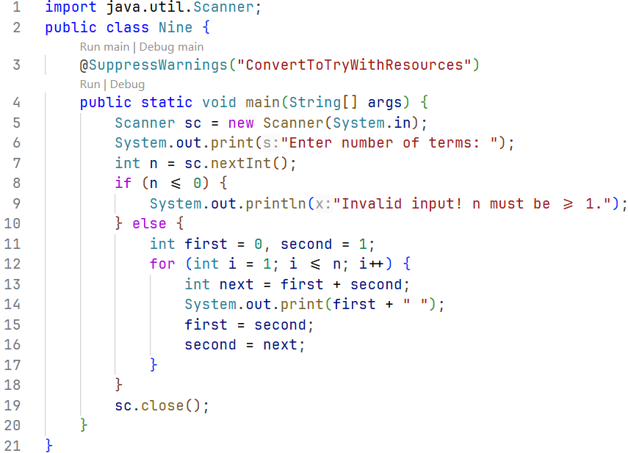
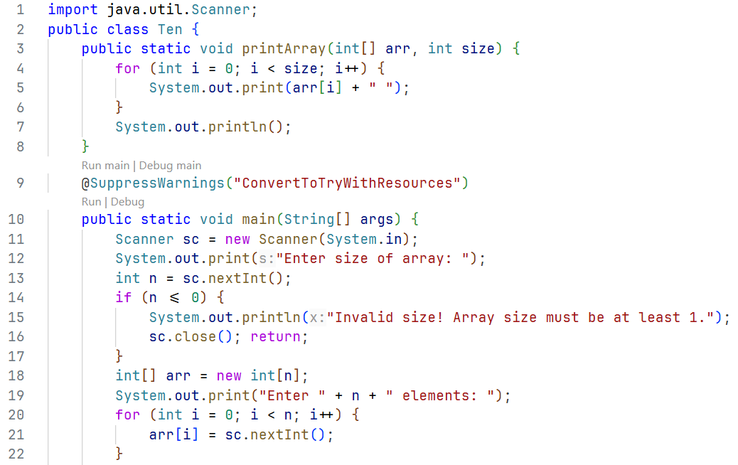
Output:
Question 10:
Write a Java program to reverse all elements of an array.
Code:
Code:
Write a program to implement Fibonacci series up to N terms (0,1,1,2,3,5....).
Question 9:
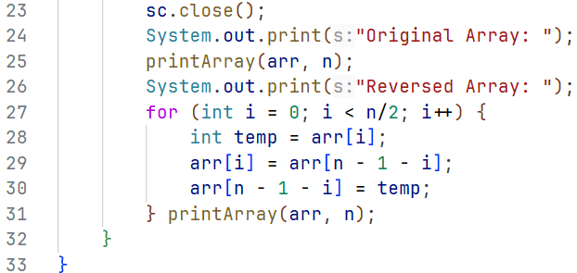
Code:
Output:

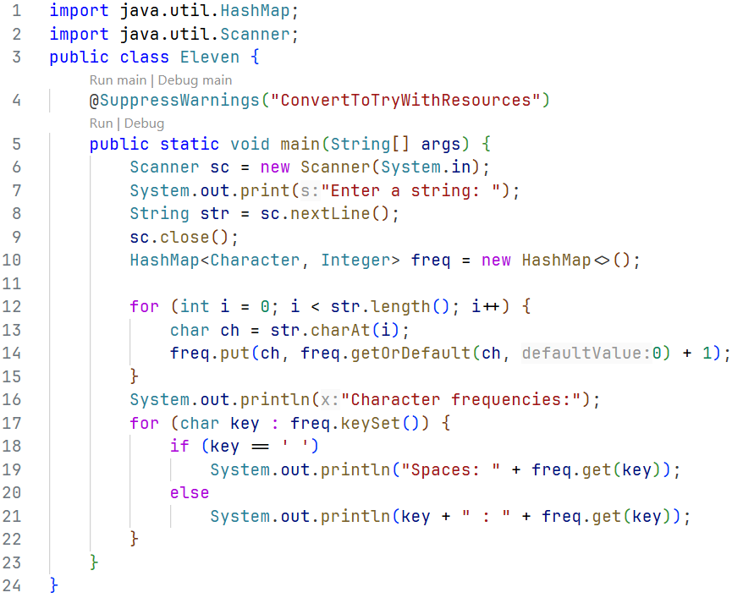
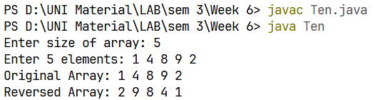
Output:
Write a Java program to find the frequency of each character in a given string.
Question 11:
Code:
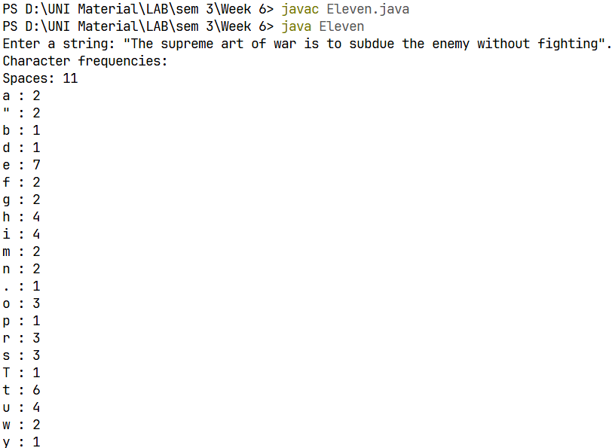
Output:

